## Conditions:

## 

Angular acceleration loads. When i simulated with this i saw nothing of concern so i blasted it to 1000 lol



Base force = 1250N → with factory of safety = 4.0

Force = 5000N

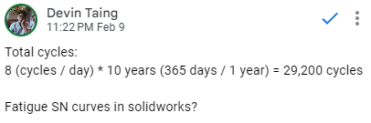

N cycles = 292000 → with safety factor = 2.0 → 60,000

## 

## Funnel stuff

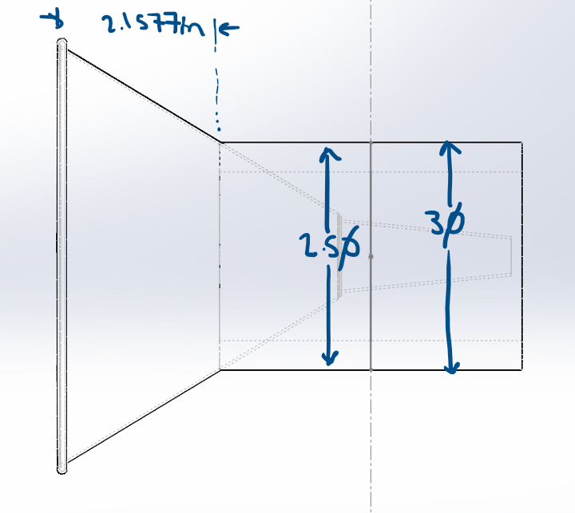

2.1557 in from the top, funnel diameter 3in

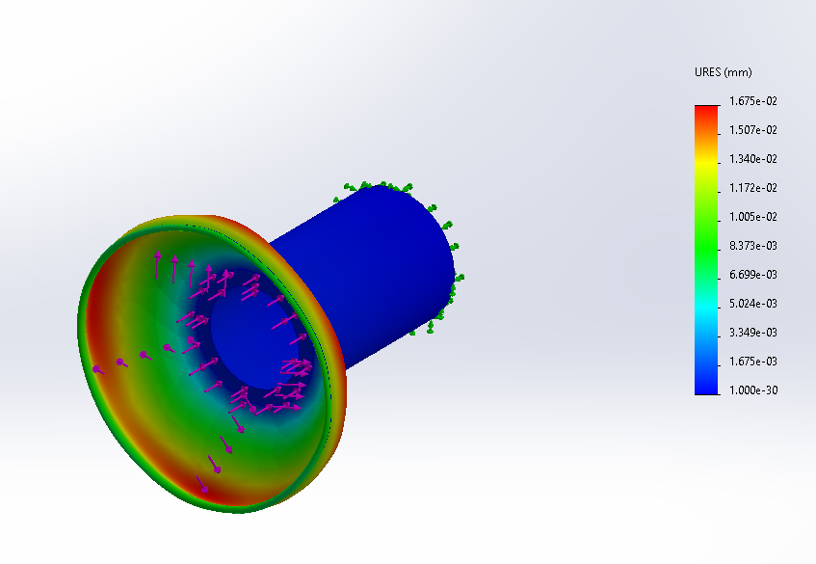

Simulation:

* Fixed at back end.
* Force applied to face of funnel and face of tube.
* Force applied: 1250N
* Max URES displacement: 1.675e-02 mm → 0.0659449 in
  + Located at edge of funnel
* Material: 1060 Aluminum alloy. Note: Funnel is tin, which is slightly weaker. Displacement might be higher. Reinforcement will probably be needed to survive fatigue and 29200 cycles lol

## Lever Lock

### Axial

Material for both: 1060 Alloy

Tested with a width of 0.35 inches → 0.44 pounds.

Thickness possibly could be 0.5 inches → 0.63 pounds.

For motor, test for max with 1 pound probably.

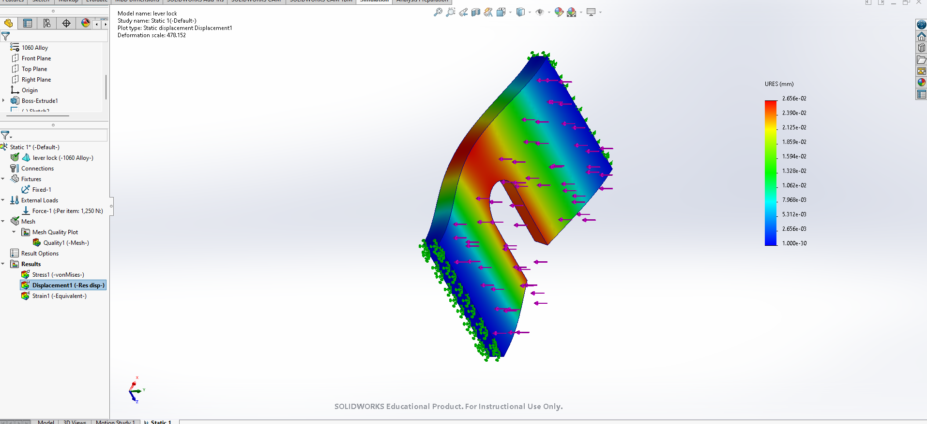

Sim specs:

* Fixed on **both** sides
* Force applied: 1250N normal to main face
  + **\*Force of coupling. This part should never see this much force. Wear and tear due to oscillation is the main load.**
* Maximum deflection occurs in center: 2.656e-02 mm → 0.001045 in

### 

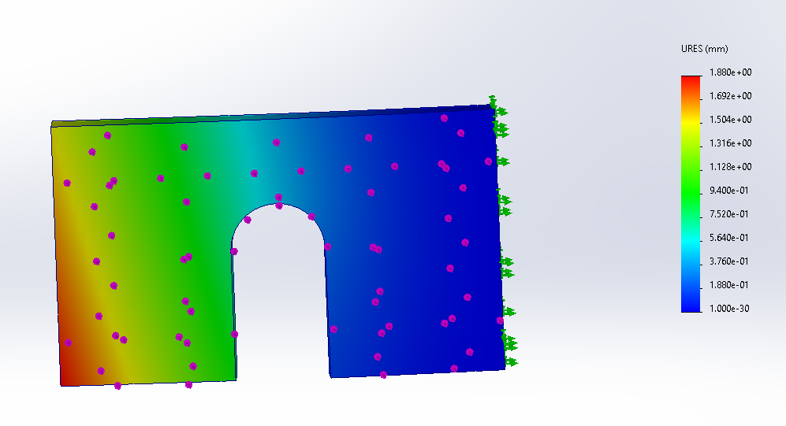

* Fixed on **one** side
* Force applied: 1250N normal to main face
* Maximum deflection occurs in center: 1.880 mm → 0.074 in
  + Bottom right edge

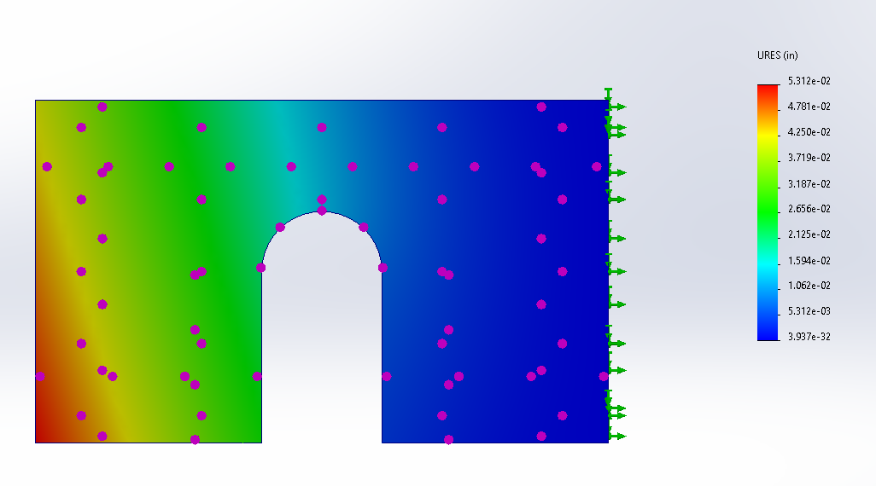

**Force=2500N, thickness = 0.5in**

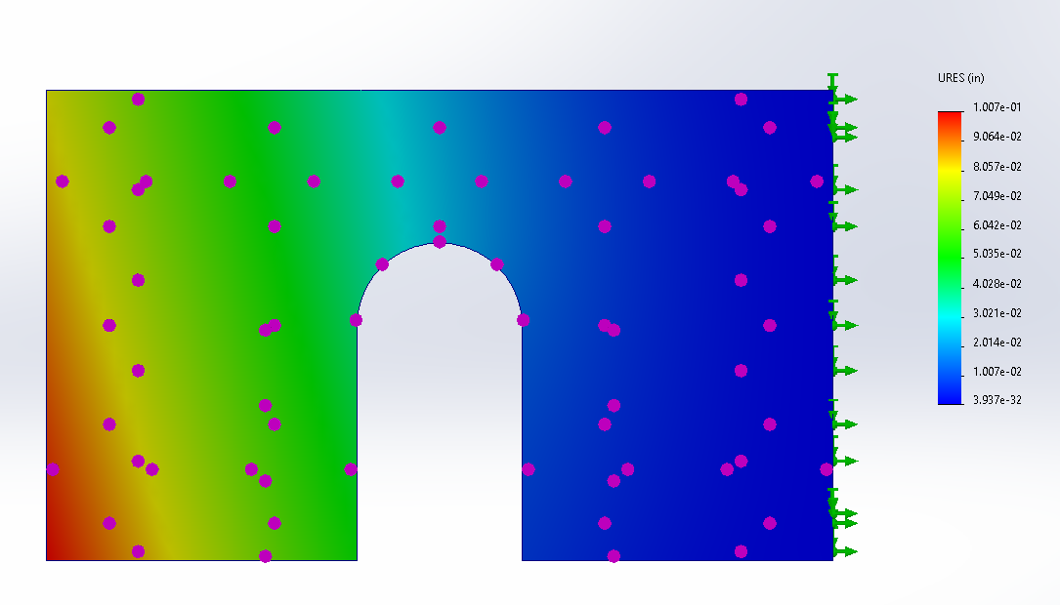

**Force=2500N, thickness = 0.4in**

### Centrifugal

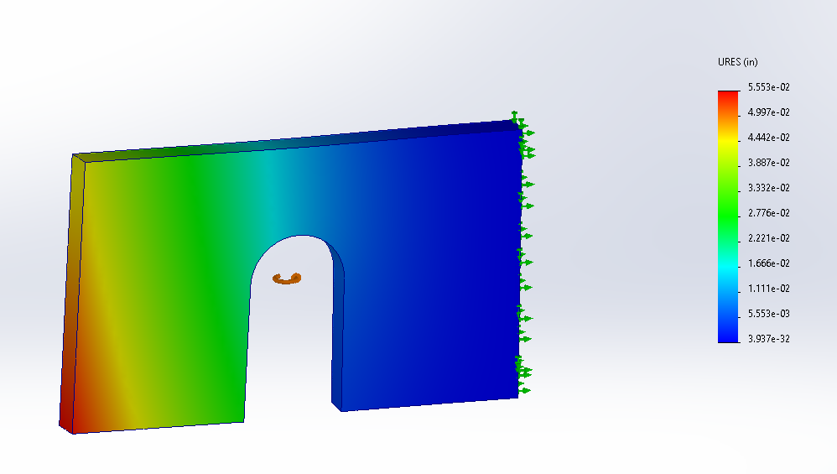

speed: 1000 rpm

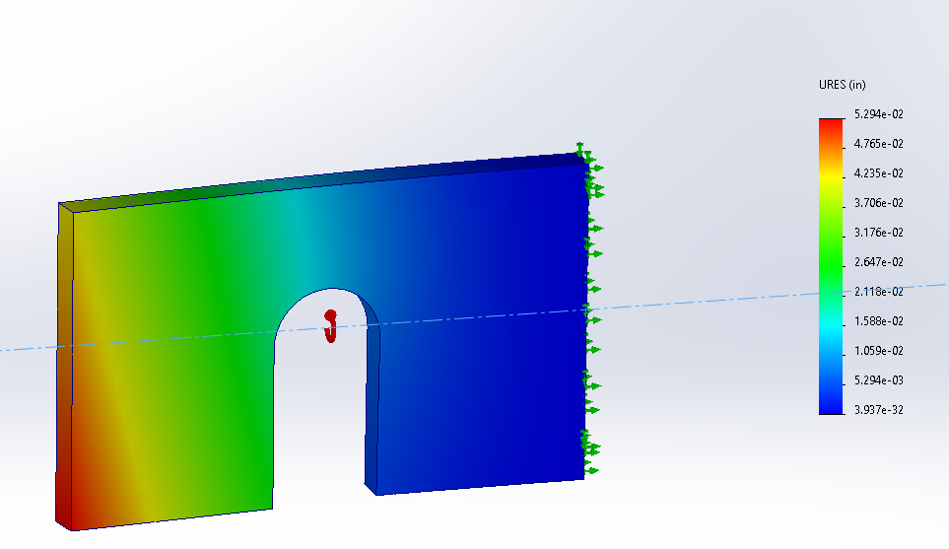

Speed: 1000 rpm

### Fatigue Axial

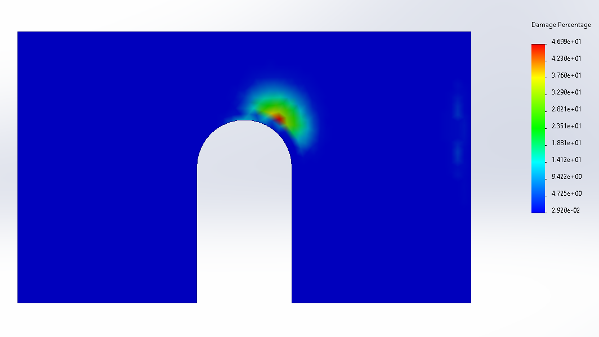

**N=29200, F=2500N, T=0.4in**

### Fatigue Centrifugal

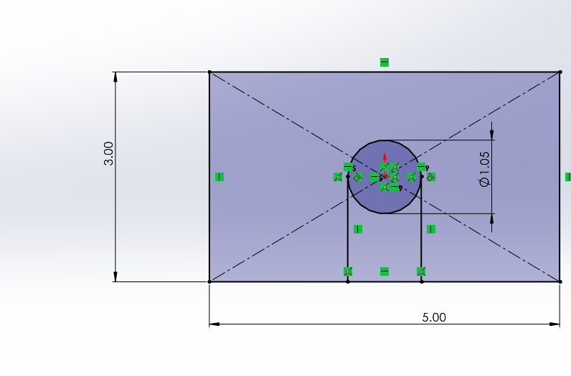

Lever lock still requires some more design attention. I tried to design one that would give the motor a hard time so we could have some safety factor.

## Male (lol)

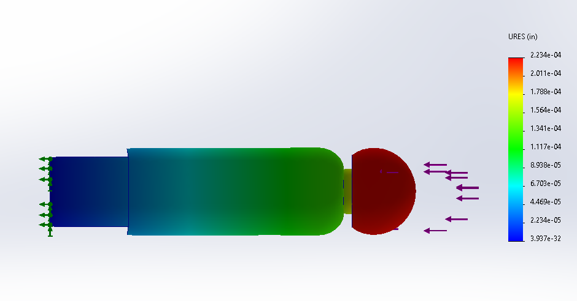

**Static 1: Force: 2500N**

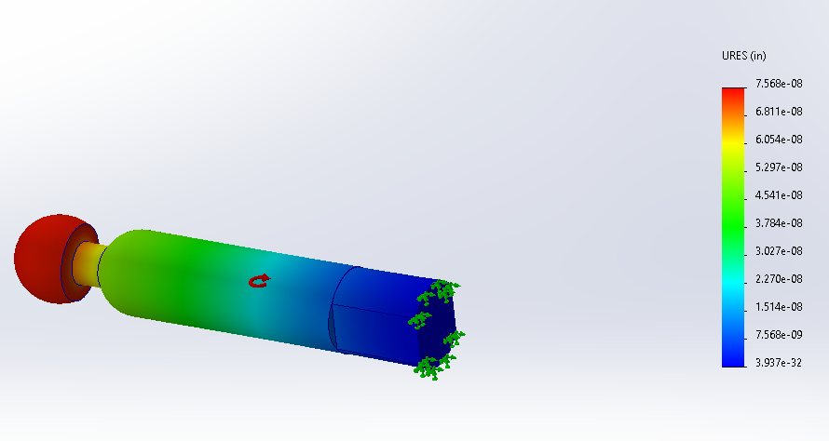

* Suppressed U-joint connect (interference caused mesh issues)
* Fixed on back
* Centrifugal force: Angular velocity = 6.28 rad/s (yaw)
* Maximum deflection occurs in center: **7.568e-08 in**
  + end
* Suppressed U-joint connect (interference caused mesh issues)
* Fixed on back
* Centrifugal force: Angular velocity = 4.19 rad/s (pitch)
* Maximum deflection occurs in center: **4.454e0-8 in**
  + End

## 

* Suppressed U-joint connect (interference caused mesh issues)
* Fixed on **back & indent**
* Centrifugal force: Angular velocity = 6.28 rad/s (yaw)
* Maximum deflection occurs in center: 8.663e-09
  + end

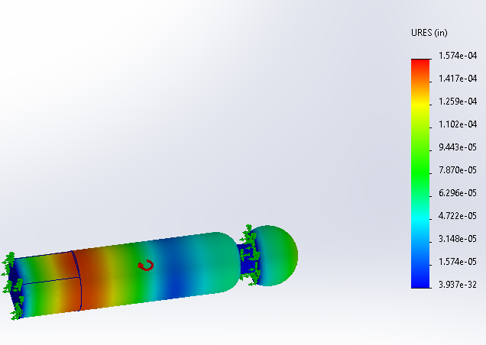

Speed: 1000 rad/s

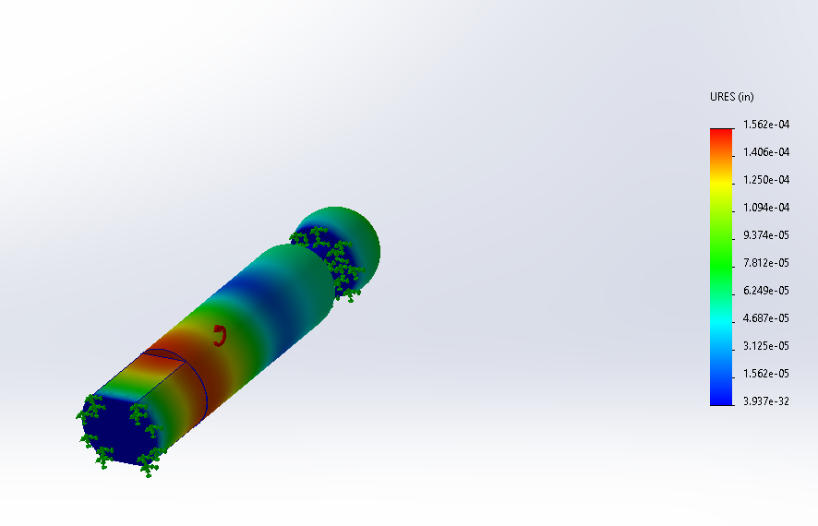

Speed: 1000 rad/s

## 

**N=29,200** with Static 1. As you can see, this thing is chilling.

## Structural

**Centrifugal**

Due to turning. Assumed 90 degree turn in ¼ second →

Don’t know about angular acceleration yet.

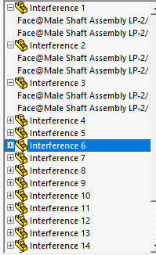

Will have to remate male connections. Interference is preventing mating and simulations will not run.

**Tension**

Should not have to consider tension. Assumption is that control systems between vehicles are synchronous and do not create any velocity differential.

**Oscillation**

Shit

How do we do this

**Fatigue**

Top bar is 1060, bottom bar is 2024

